Day: 17 (04-11-2026) | Multiple dataset ingestion and transformation in Snowflake | Documented By:
Task – 2 | Multiple dataset ingestion and transformation in Snowflake | Sujit T K

- Setup database, schema and warehouse
CREATE DATABASE IF NOT EXISTS AJI_DB_V2;
CREATE SCHEMA IF NOT EXISTS AJI_DB_V2.AJI_SCHEMA_V2;

USE SCHEMA AJI_DB_V2.AJI_SCHEMA_V2;

CREATE WAREHOUSE IF NOT EXISTS AJI_WAREHOUSE_V2
WAREHOUSE_SIZE = 'SMALL'
AUTO_SUSPEND = 60
AUTO_RESUME = TRUE
INITIALLY_SUSPENDED = TRUE;

USE WAREHOUSE AJI_WAREHOUSE_V2;
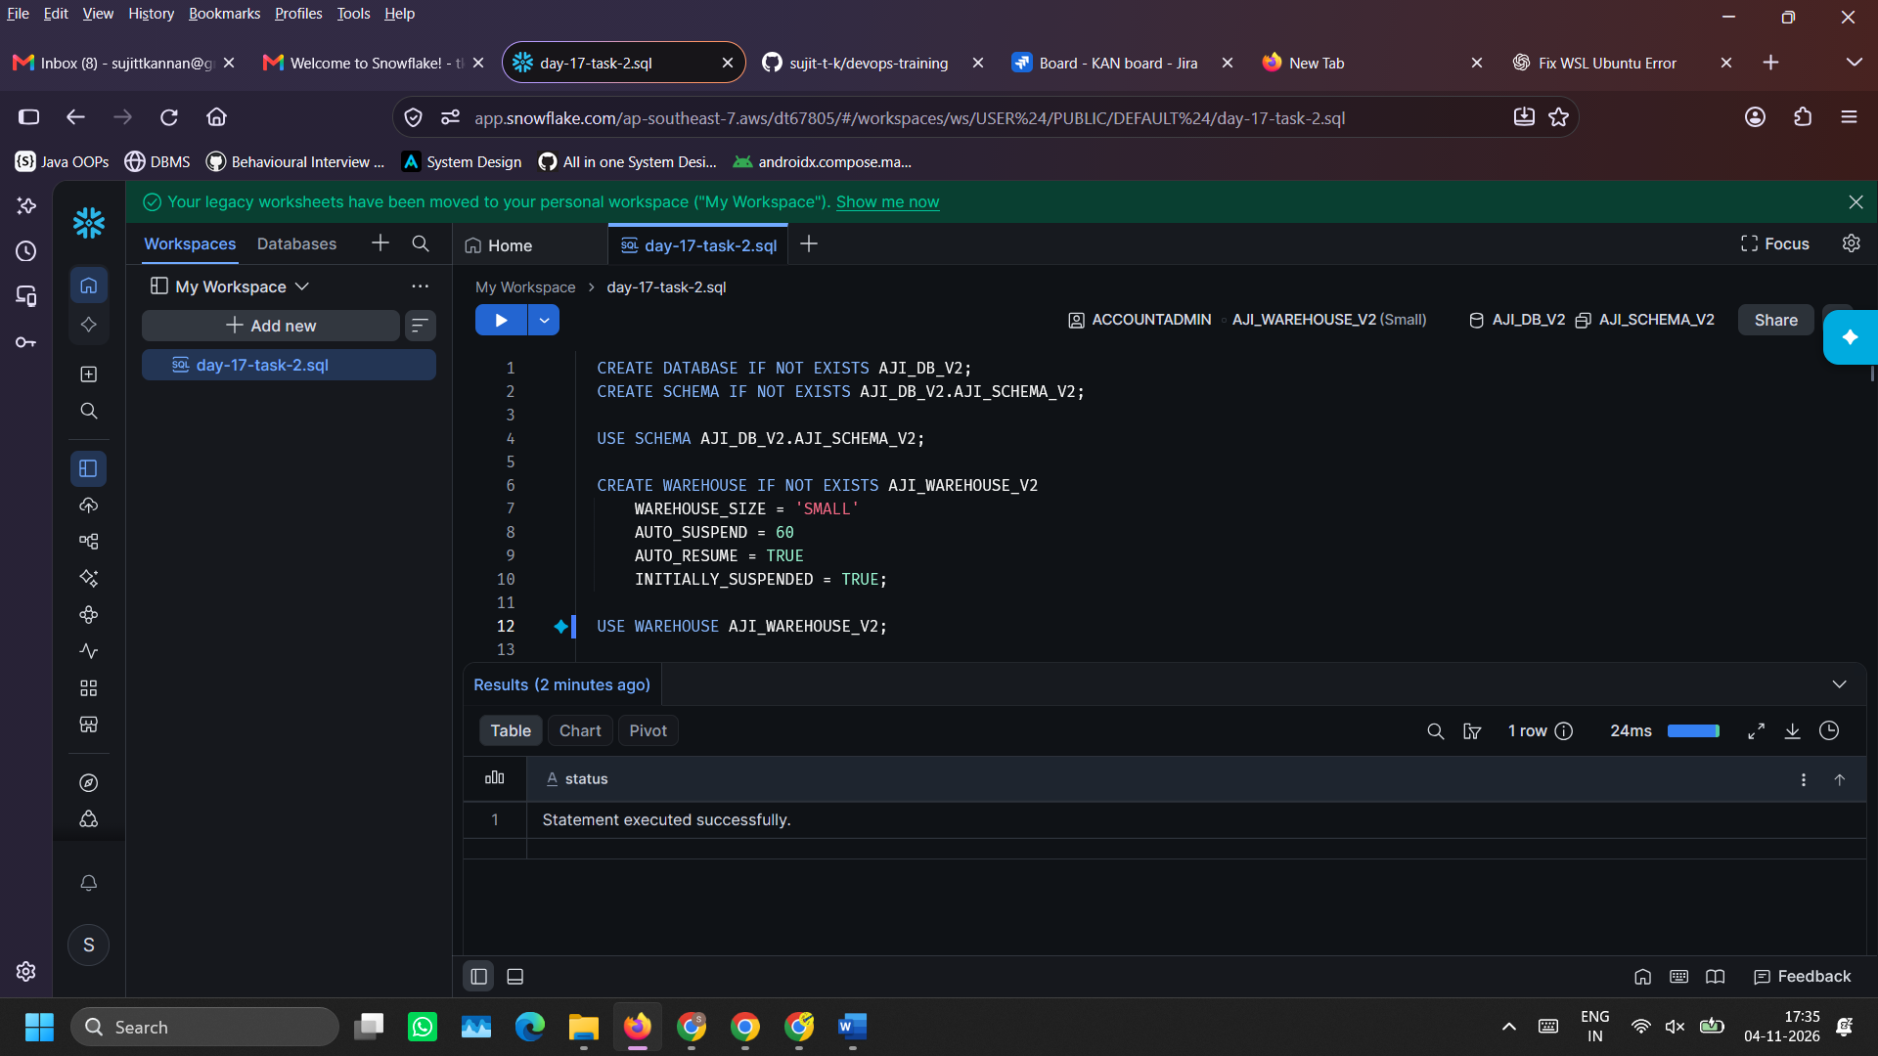
- Create tables: Customers, Products, Orders (to hold data)
CREATE OR REPLACE TABLE CUSTOMERS (
CUSTOMER_ID VARCHAR(16),
CUSTOMER_NAME VARCHAR(64),
CITY VARCHAR(32),
SIGNUP_DATE DATE,
CUSTOMER_TIER VARCHAR(16)
);

CREATE OR REPLACE TABLE PRODUCTS (
PRODUCT_ID VARCHAR(16),
PRODUCT_NAME VARCHAR(64),
PRODUCT_CATEGORY VARCHAR(32),
UNIT_PRICE NUMBER(10,2),
STOCK_QUANTITY INT
);

CREATE OR REPLACE TABLE ORDERS (
ORDER_ID VARCHAR(16),
CUSTOMER_ID VARCHAR(16),
PRODUCT_ID VARCHAR(16),
QUANTITY INT,
ORDER_DATETIME TIMESTAMP_NTZ,
ORDER_STATUS VARCHAR(16),
PAYMENT_MODE VARCHAR(16)
);
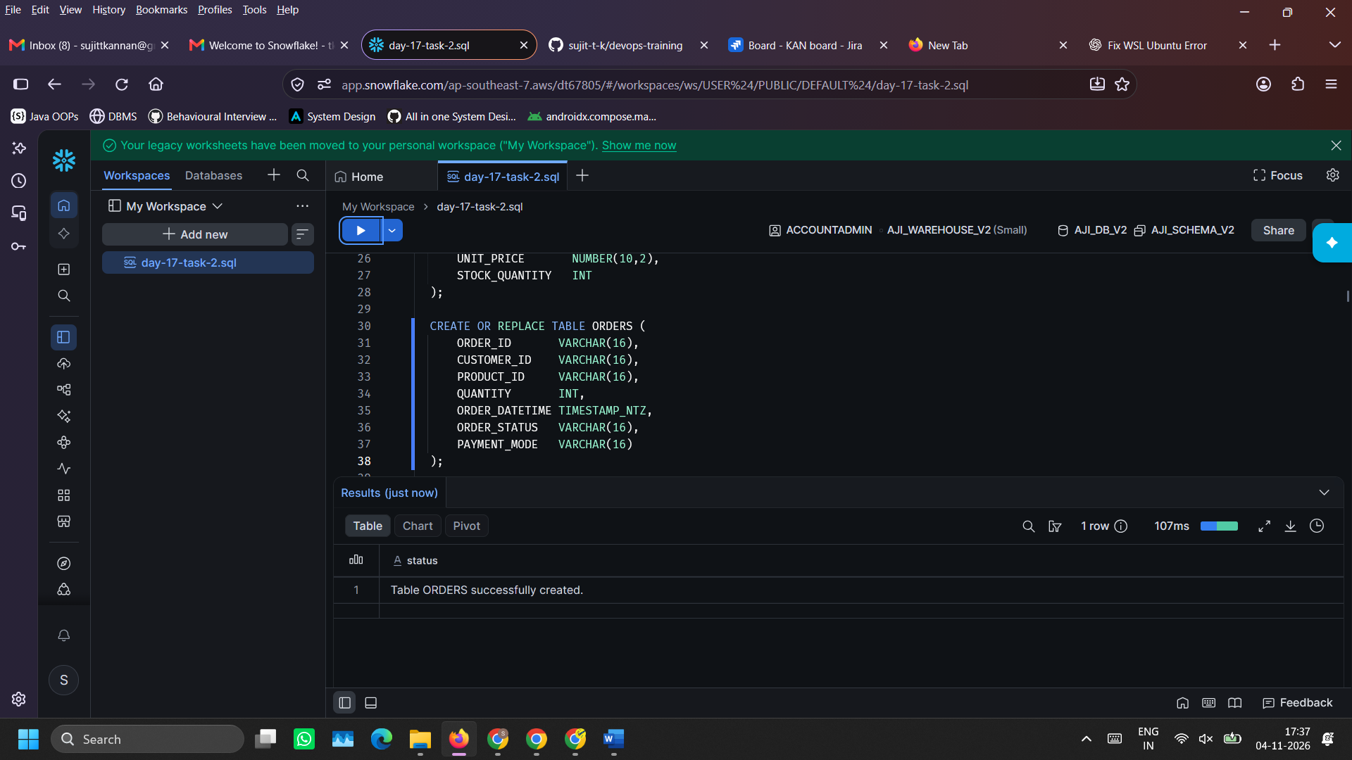
- Create file format and stage (so that the files can be uploaded into snowflake environment)
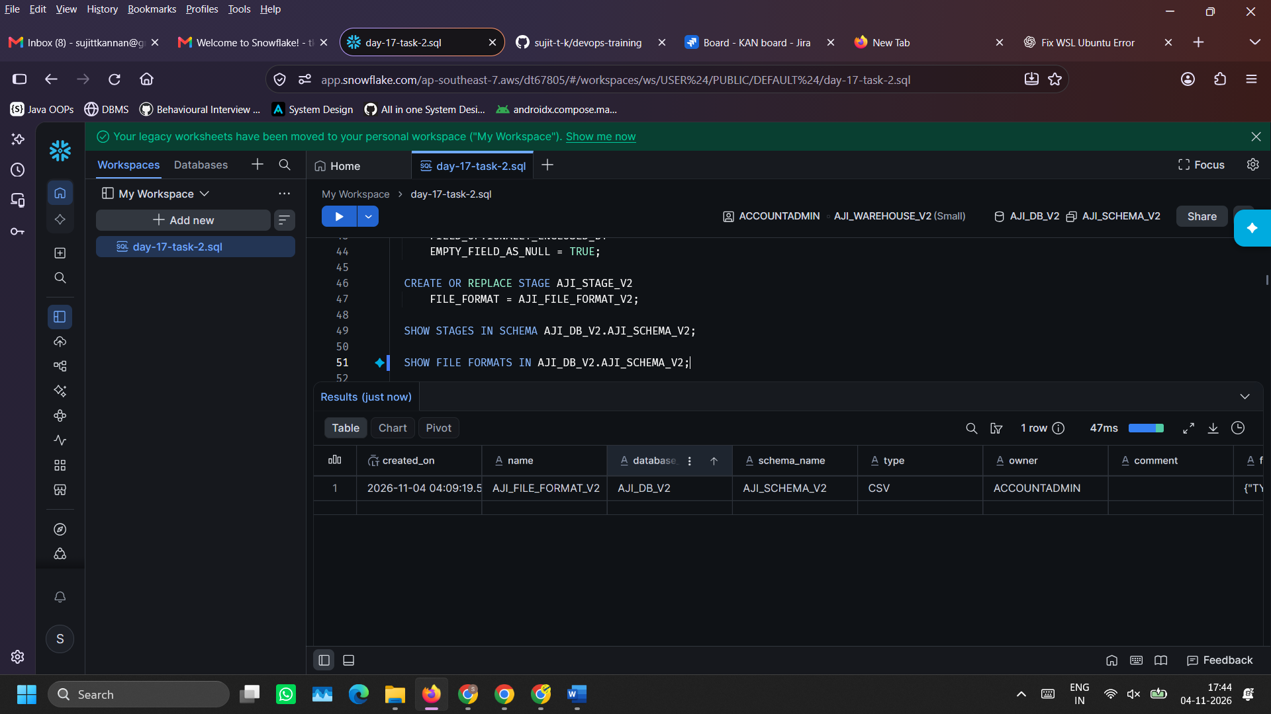
CREATE OR REPLACE FILE FORMAT AJI_FILE_FORMAT_V2
TYPE = CSV
SKIP_HEADER = 1
FIELD_OPTIONALLY_ENCLOSED_BY = '"'
EMPTY_FIELD_AS_NULL = TRUE;

CREATE OR REPLACE STAGE AJI_STAGE_V2
FILE_FORMAT = AJI_FILE_FORMAT_V2;

SHOW STAGES IN SCHEMA AJI_DB_V2.AJI_SCHEMA_V2;

SHOW FILE FORMATS IN AJI_DB_V2.AJI_SCHEMA_V2;

- Upload .csv files into the stage
- Click on ‘Catalog’ tab on the left sidebar and then go to Explorer -> AJI_DB_V2 -> AJI_SCHEMA_V2 -> Stages -> AJI_STAGE_V2.
- Then on the top right, you can find ‘Upload Files’ button. Click on it, a file chooser will open. Upload all files and wait till it gets uploaded.
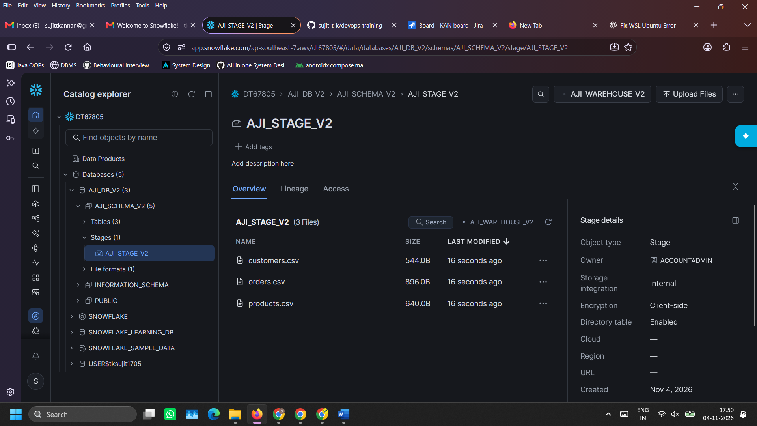

- Verify files upload into the stage using SQL
LIST @DB_AJI_V2.AJI_STAGE_V2;
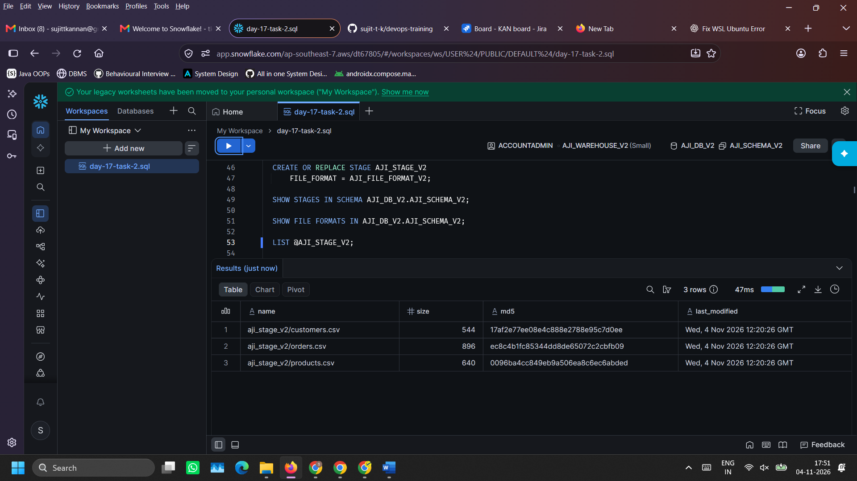
- Load data into tables using COPY INTO command
COPY INTO CUSTOMERS
FROM @AJI_STAGE_V2
FILES = ('customers.csv')
FILE_FORMAT = (FORMAT_NAME = 'AJI_FILE_FORMAT_V2')
ON_ERROR = 'ABORT_STATEMENT';

COPY INTO PRODUCTS
FROM @AJI_STAGE_V2
FILES = ('products.csv')
FILE_FORMAT = (FORMAT_NAME = 'AJI_FILE_FORMAT_V2')
ON_ERROR = 'ABORT_STATEMENT';

COPY INTO ORDERS
FROM @AJI_STAGE_V2
FILES = ('orders.csv')
FILE_FORMAT = (FORMAT_NAME = 'AJI_FILE_FORMAT_V2')
ON_ERROR = 'ABORT_STATEMENT';
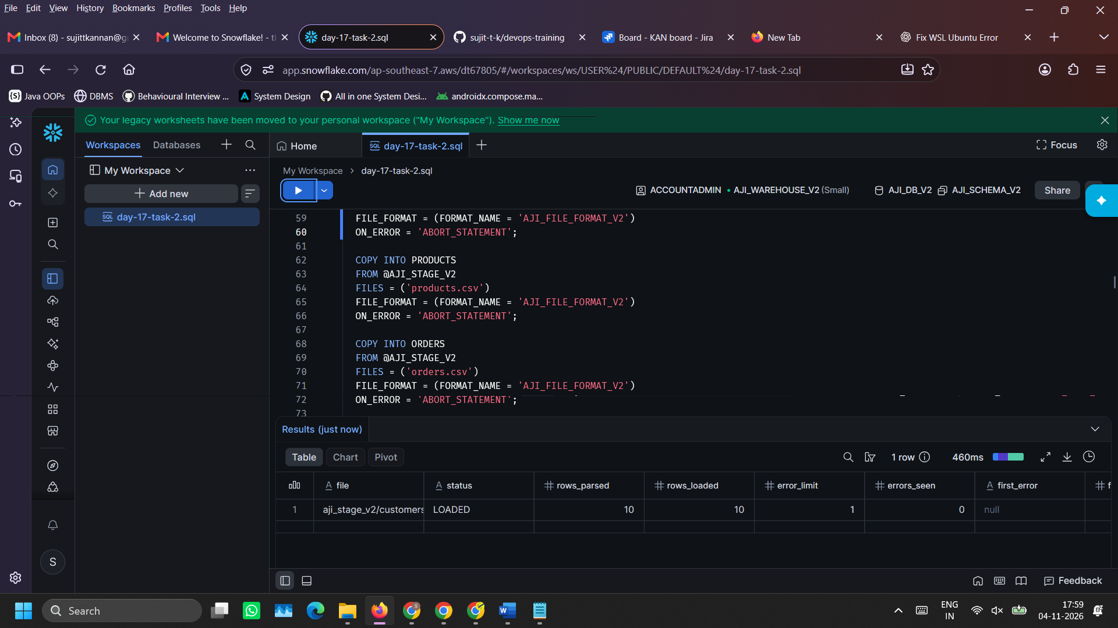
- Transform data (data cleaning) and save it in new table
CREATE OR REPLACE TABLE CLEAN_CUSTOMERS AS
SELECT
TRIM(CUSTOMER_ID) AS CUSTOMER_ID,
TRIM(COALESCE(CUSTOMER_NAME, 'UNKNOWN CUSTOMER')) AS CUSTOMER_NAME,
UPPER(TRIM(CITY)) AS CITY,
SIGNUP_DATE,
UPPER(TRIM(CUSTOMER_TIER)) AS CUSTOMER_TIER
FROM CUSTOMERS;

CREATE OR REPLACE TABLE CLEAN_PRODUCTS AS
SELECT
TRIM(PRODUCT_ID) AS PRODUCT_ID,
TRIM(PRODUCT_NAME) AS PRODUCT_NAME,
INITCAP(TRIM(PRODUCT_CATEGORY)) AS PRODUCT_CATEGORY,
UNIT_PRICE,
STOCK_QUANTITY
FROM PRODUCTS;

CREATE OR REPLACE TABLE CLEAN_ORDERS AS
SELECT
TRIM(ORDER_ID) AS ORDER_ID,
TRIM(CUSTOMER_ID) AS CUSTOMER_ID,
TRIM(PRODUCT_ID) AS PRODUCT_ID,
QUANTITY,
ORDER_DATETIME,
INITCAP(TRIM(ORDER_STATUS)) AS ORDER_STATUS,
TRIM(PAYMENT_MODE) AS PAYMENT_MODE
FROM ORDERS;

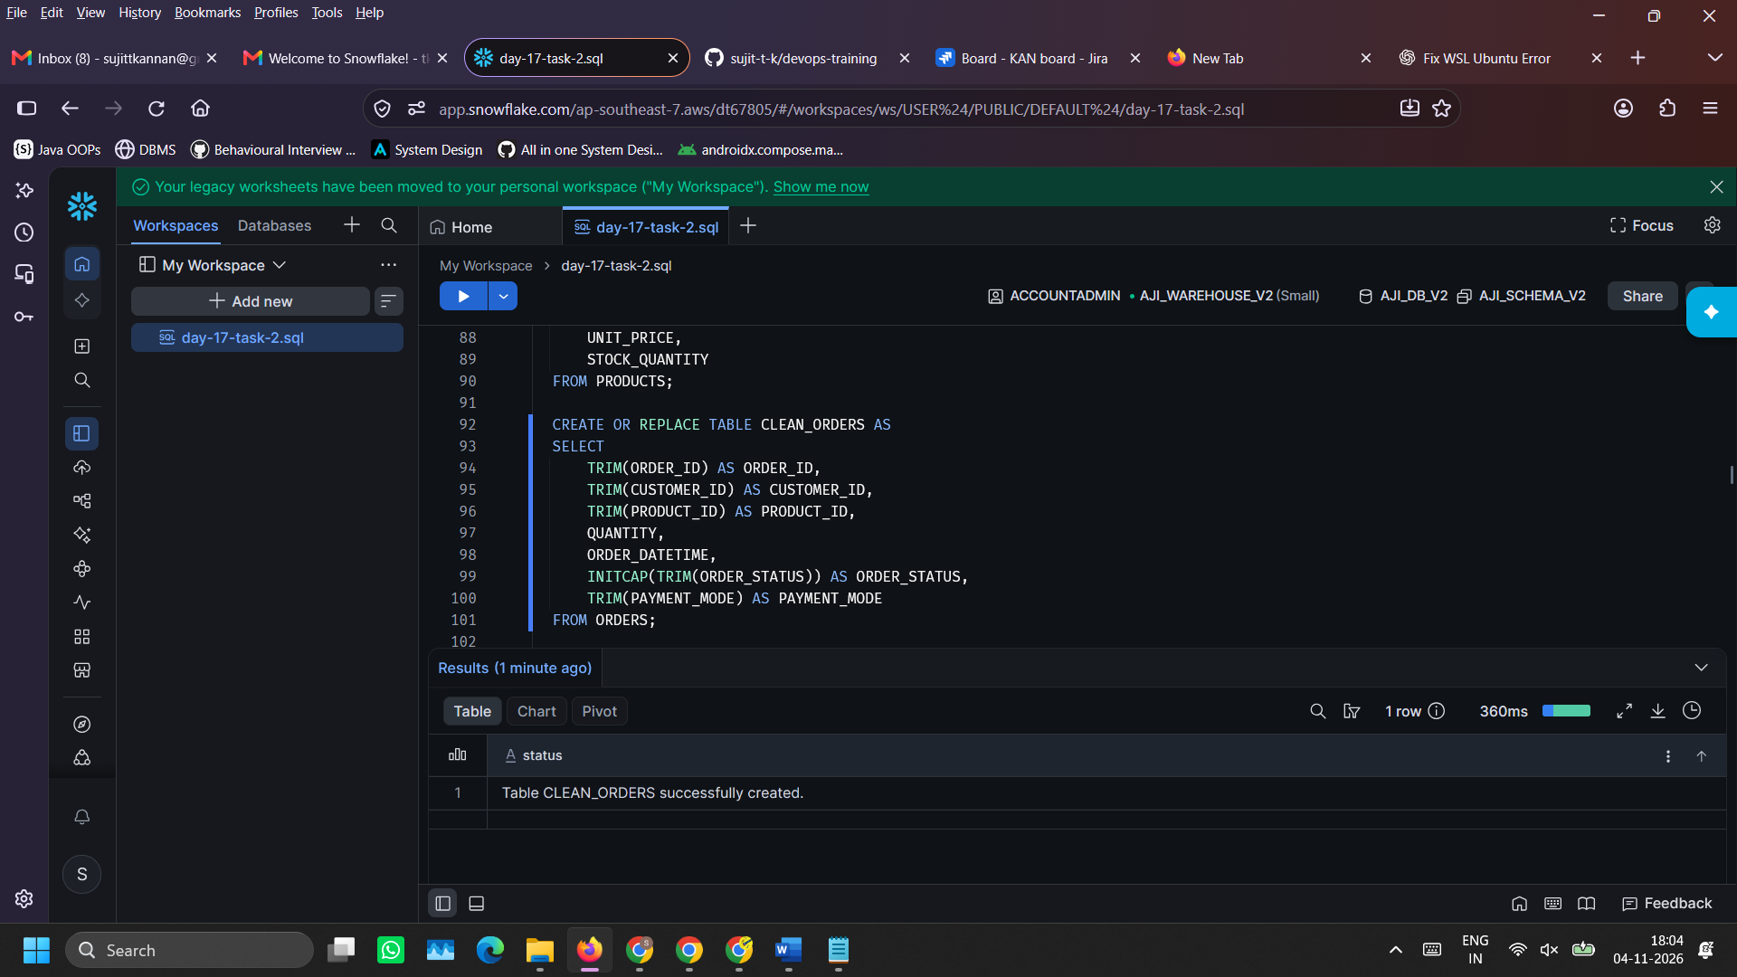

- Validate cleaned table entries (to ensure that new table holds data)
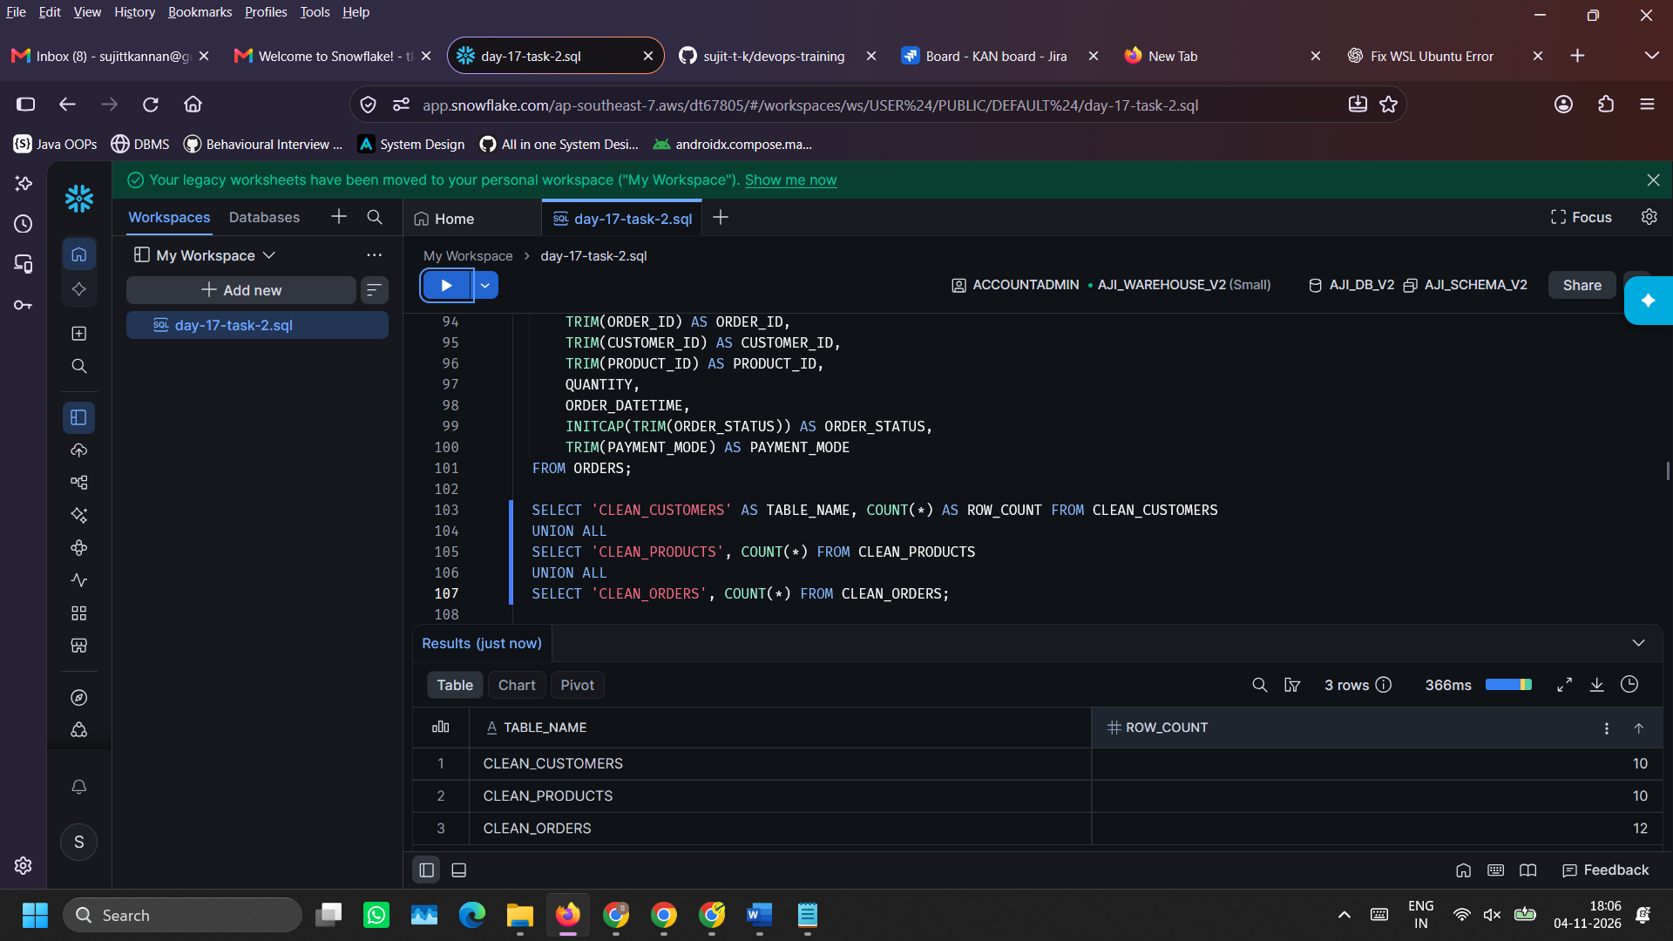
SELECT 'CLEAN_CUSTOMERS' AS TABLE_NAME, COUNT(*) AS ROW_COUNT FROM CLEAN_CUSTOMERS
UNION ALL
SELECT 'CLEAN_PRODUCTS', COUNT(*) FROM CLEAN_PRODUCTS
UNION ALL
SELECT 'CLEAN_ORDERS', COUNT(*) FROM CLEAN_ORDERS;

- Perform analytical queries
9.1) JOIN: Query to identify customers who have never made even a single order
SELECT
c.CUSTOMER_ID,
c.CUSTOMER_NAME,
c.CITY,
c.SIGNUP_DATE,
c.CUSTOMER_TIER
FROM CLEAN_CUSTOMERS c
LEFT JOIN CLEAN_ORDERS o ON c.CUSTOMER_ID = o.CUSTOMER_ID
WHERE o.ORDER_ID IS NULL;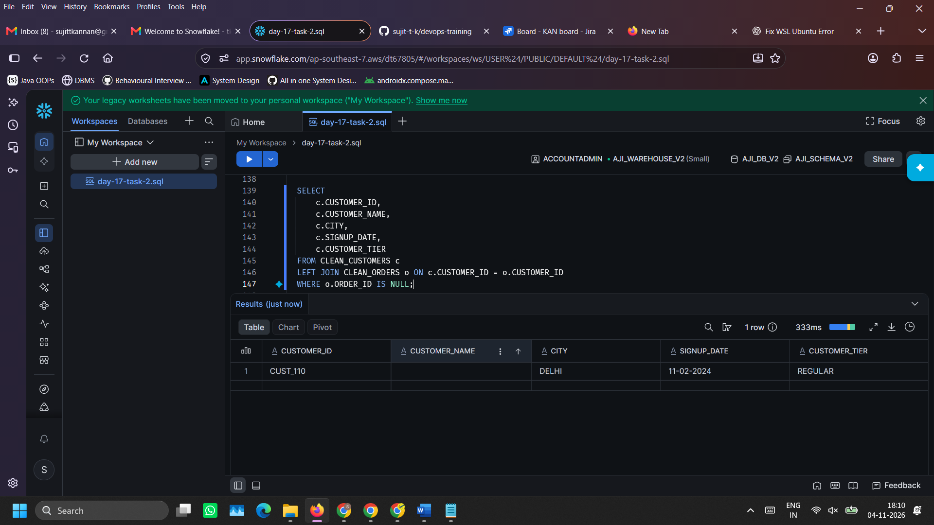

OBSERVATION FROM THE OUTPUT: The customer’s name is empty but it does not get replaced with ‘UNKNOWN CUSTOMER’
VERDICT: COALESCE() only REPLACES NULL values, it DOES NOT REPLACES non-null, empty values

9.2) JOIN, GROUPING, AGGREGATION, FILTERING, SORTING: Revenue generated across each city
SELECT
c.CITY,
COUNT(o.ORDER_ID) AS ORDERS_COUNT,
SUM(o.QUANTITY * p.UNIT_PRICE) AS REVENUE
FROM CLEAN_ORDERS o
JOIN CLEAN_CUSTOMERS c ON o.CUSTOMER_ID = c.CUSTOMER_ID
JOIN CLEAN_PRODUCTS p ON o.PRODUCT_ID = p.PRODUCT_ID
WHERE o.ORDER_STATUS = 'Delivered'
GROUP BY c.CITY
ORDER BY c.CITY ASC, REVENUE DESC;
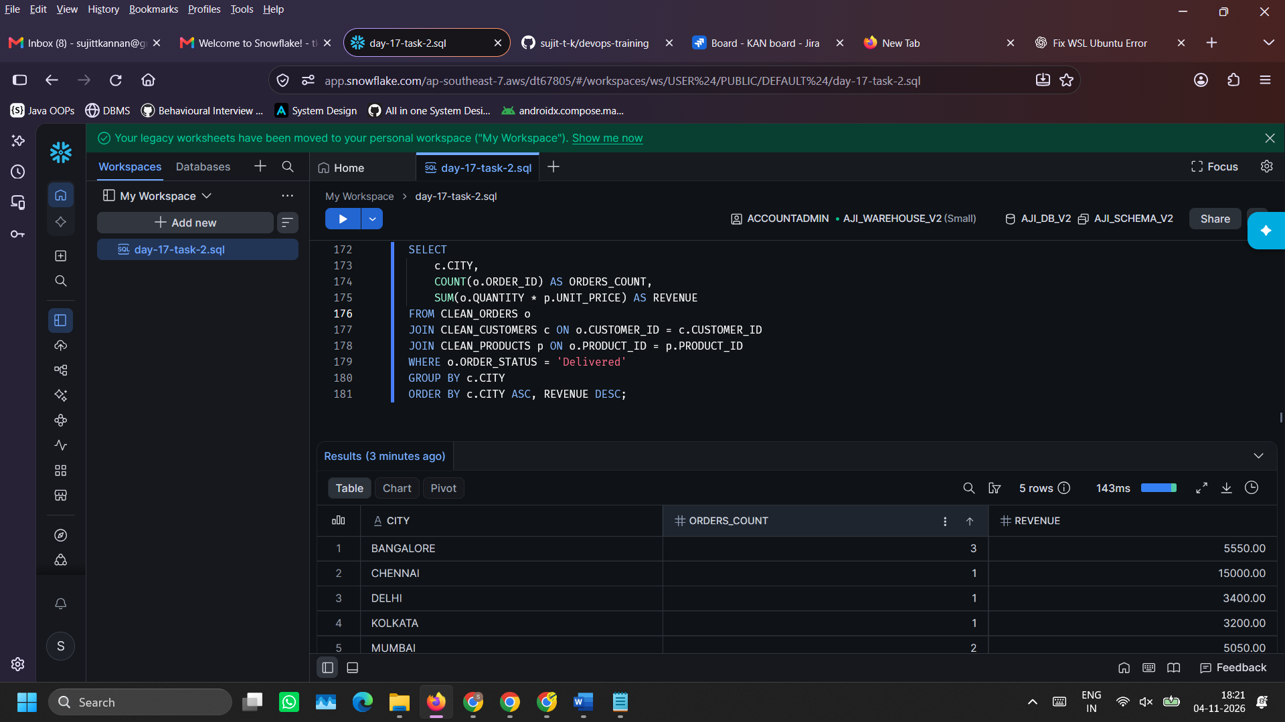

9.3) JOIN, GROUPING, AGGREGATION, SORTING: Product category-wise analysis on total orders and revenue
SELECT
p.PRODUCT_CATEGORY,
COUNT(o.ORDER_ID) AS ORDERS_COUNT,
SUM(o.QUANTITY) AS TOTAL_QUANTITY_SOLD,
SUM(o.QUANTITY * p.UNIT_PRICE) AS TOTAL_REVENUE,
ROUND(AVG(o.QUANTITY * p.UNIT_PRICE), 2) AS AVG_ORDER_VALUE
FROM CLEAN_ORDERS o
JOIN CLEAN_PRODUCTS p ON o.PRODUCT_ID = p.PRODUCT_ID
WHERE o.ORDER_STATUS = 'Delivered'
GROUP BY p.PRODUCT_CATEGORY
ORDER BY TOTAL_REVENUE DESC;
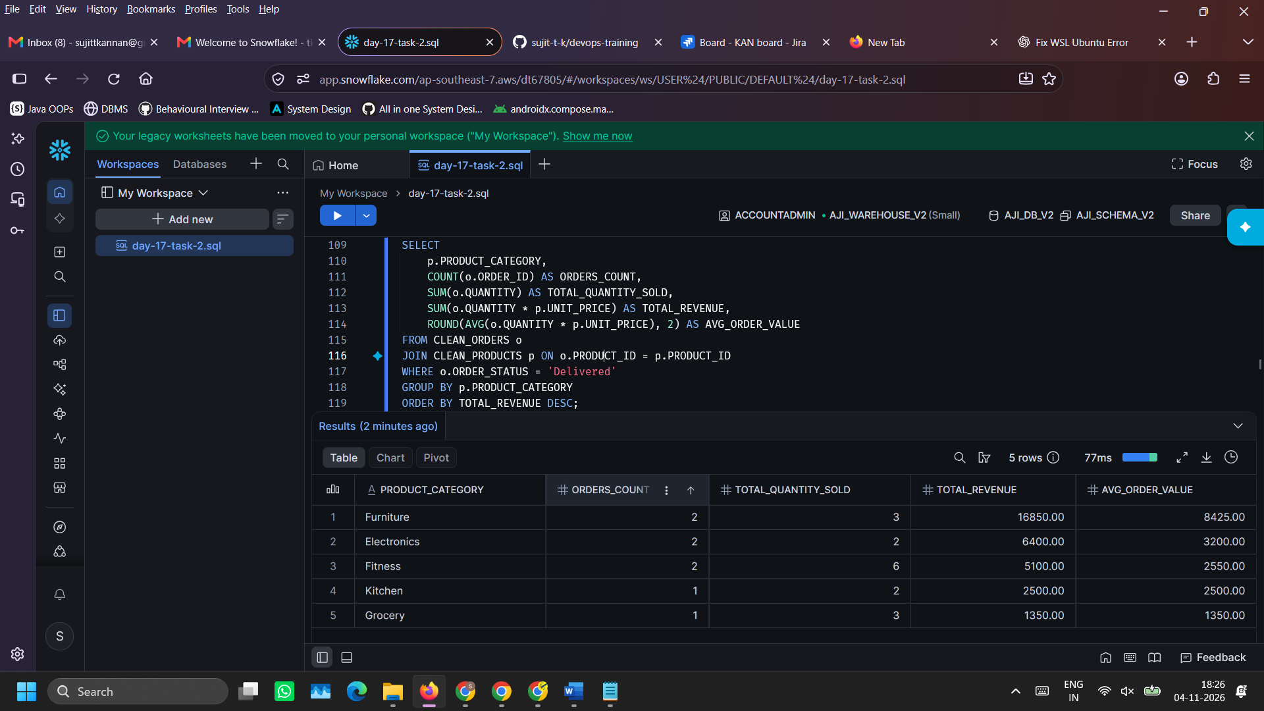
- Review query profile for optimization
- On the left side bar, click on ‘Monitoring’ tab.
- Then go to ‘Query History’. It will show all the individual queries that were executed.
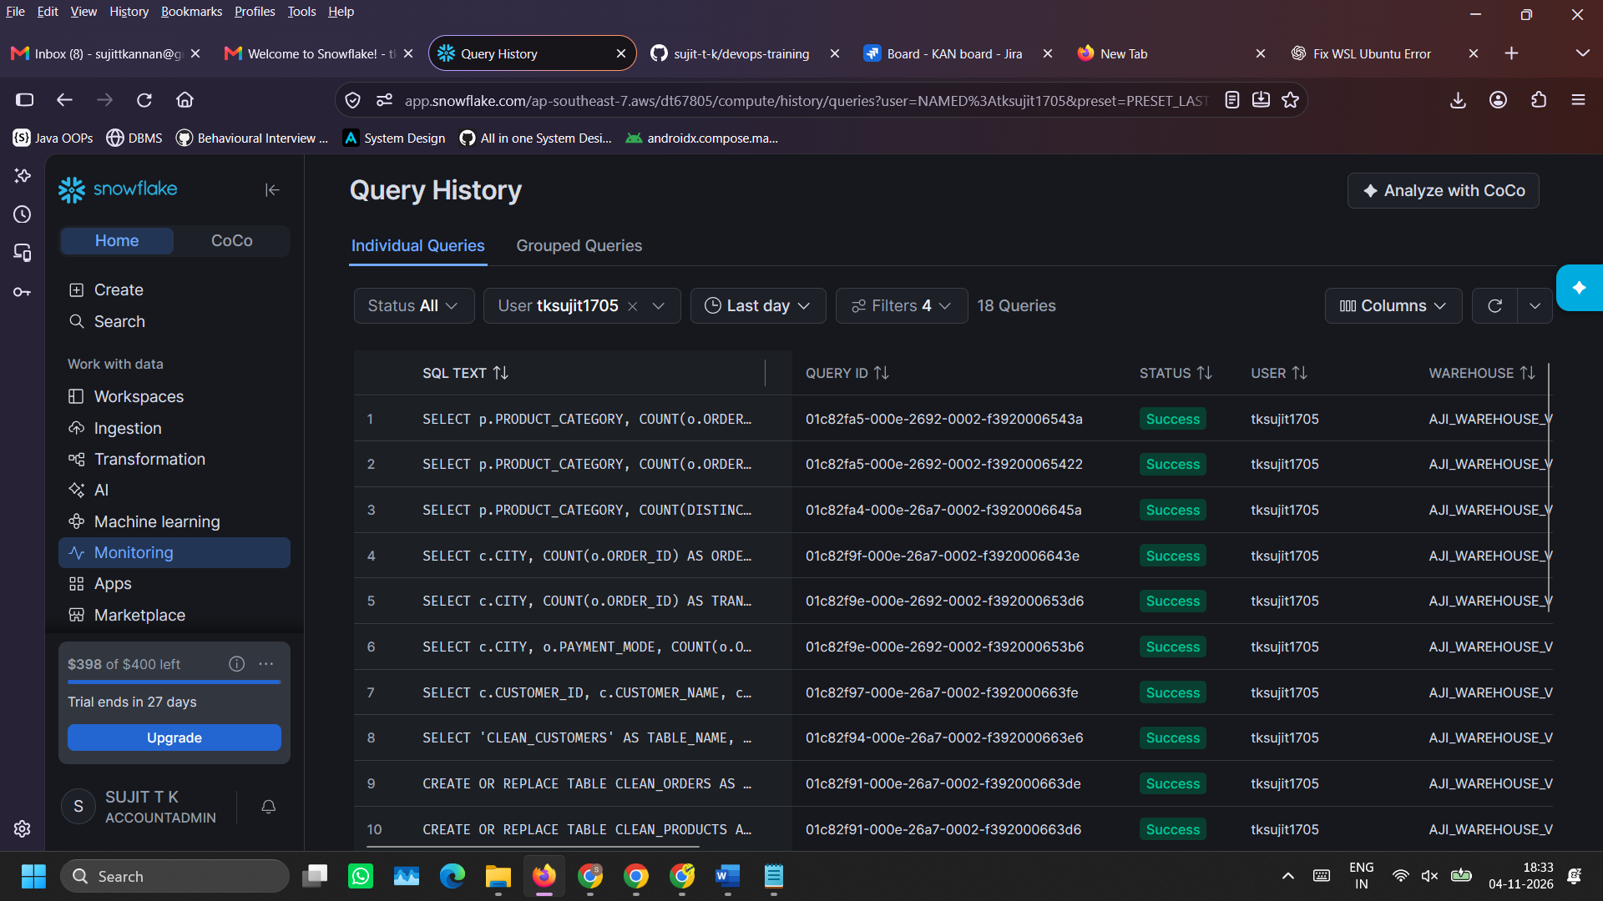

- Click on any of the queries to view the query information in detail.
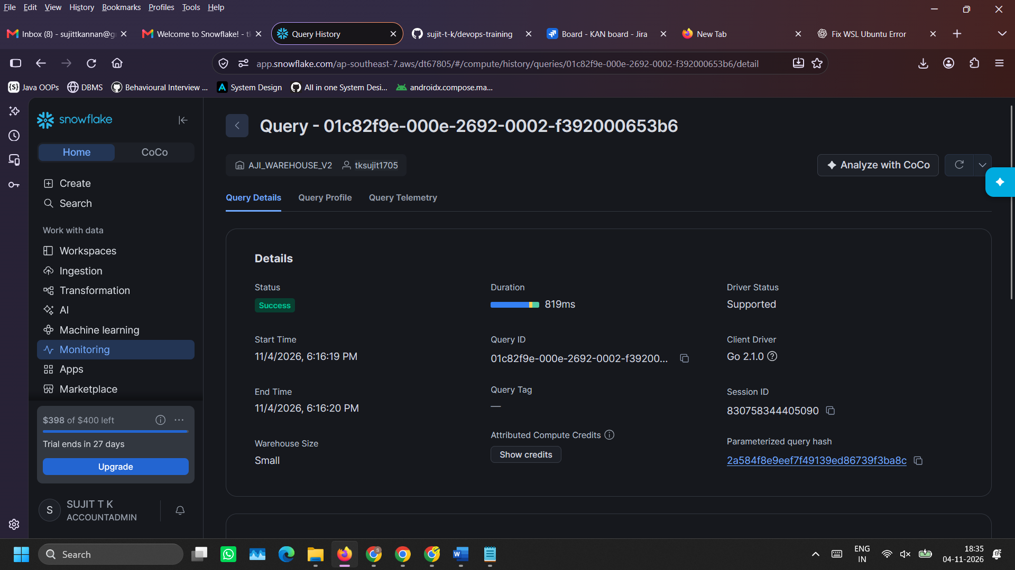

Click on ‘Query Profile’ tab to view query insights. This helps in identifying which part of the SQL consumed more compute resources, so that the query can be optimized further.
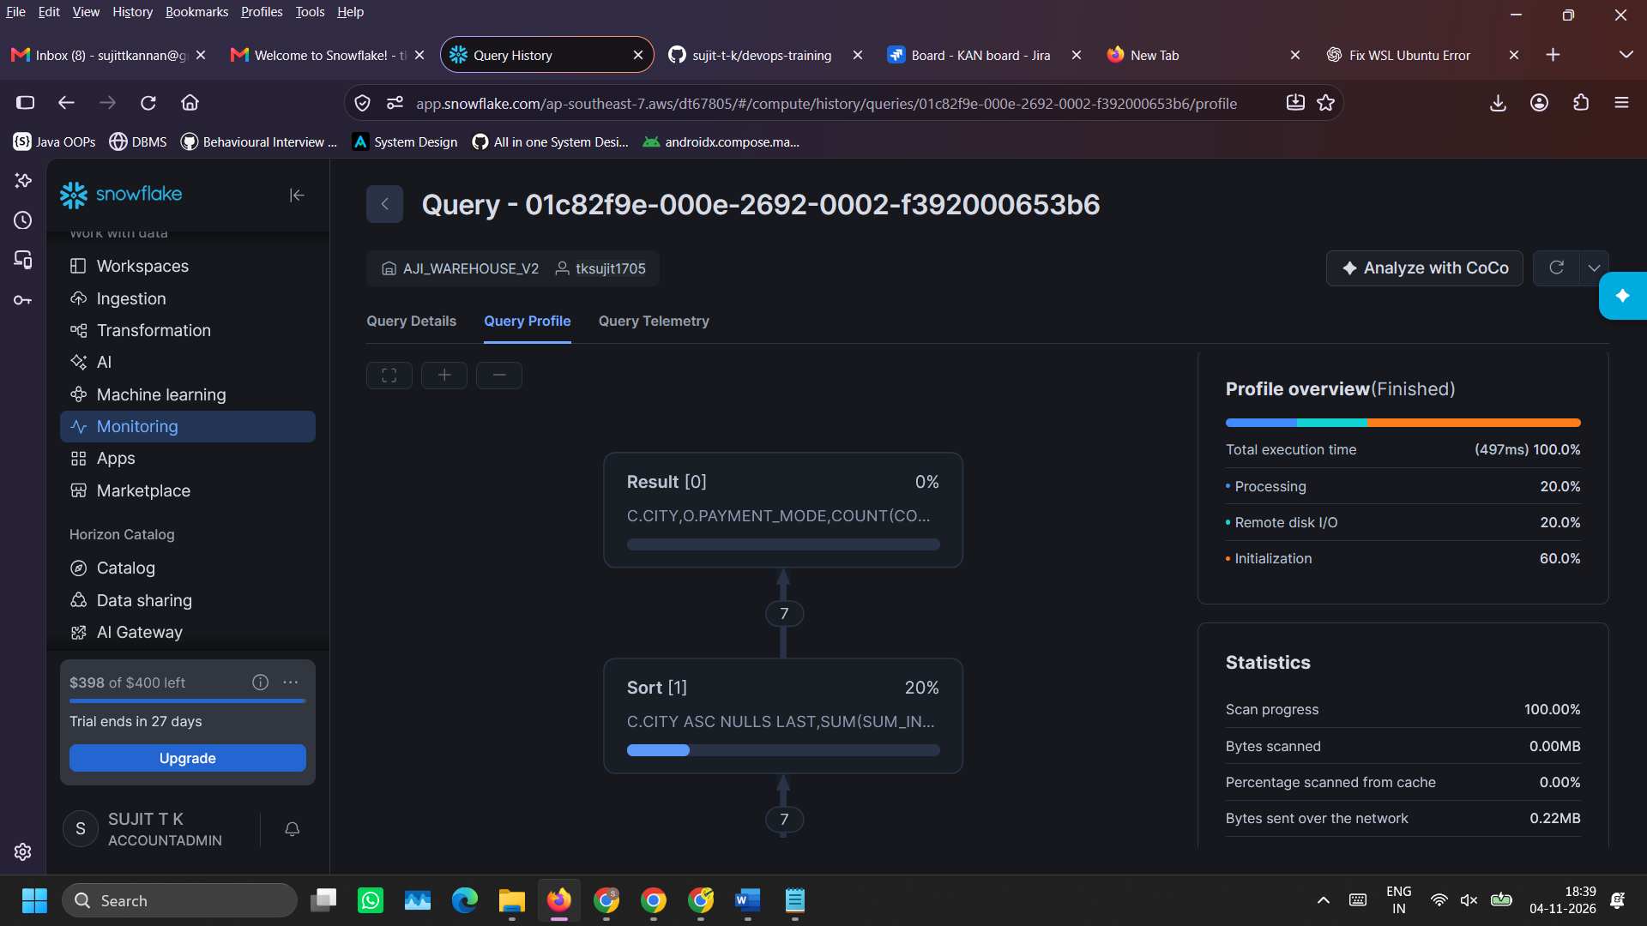
- Delete Tables, warehouses, schema and database for cleanup to avoid additional charges
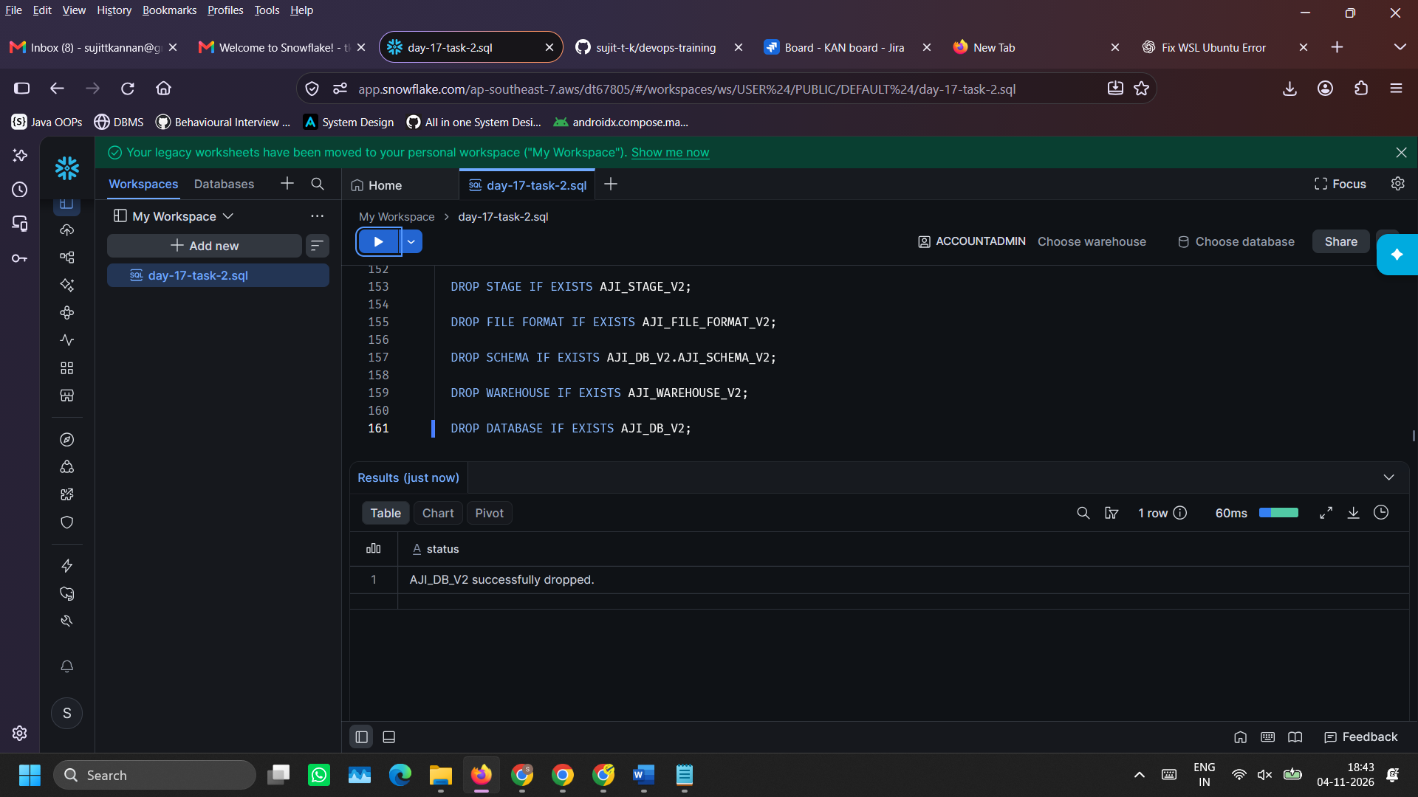
DROP TABLE IF EXISTS CLEAN_ORDERS;
DROP TABLE IF EXISTS CLEAN_PRODUCTS;
DROP TABLE IF EXISTS CLEAN_CUSTOMERS;
DROP TABLE IF EXISTS ORDERS;
DROP TABLE IF EXISTS PRODUCTS;
DROP TABLE IF EXISTS CUSTOMERS;

DROP STAGE IF EXISTS AJI_STAGE_V2;

DROP FILE FORMAT IF EXISTS AJI_FILE_FORMAT_V2;

DROP SCHEMA IF EXISTS AJI_DB_V2.AJI_SCHEMA_V2;

DROP WAREHOUSE IF EXISTS AJI_WAREHOUSE_ V2;

DROP DATABASE IF EXISTS AJI_DB_V2;

